UID EX 10
Roll:240701012
Name:Abishaa.R
AIM:
The aim is to create interactive data visualizations such as bar charts and pie charts for an online grocery sales analysis system using JavaScript
PROCEDURE:
Step 1:
Set up the HTML file to create the basic structure of the webpage. Include canvas elements to display charts.

Step 2:
Add required libraries (such as Chart.js) using CDN in the HTML file.

Step 3:
Create a JavaScript file (script.js) to store grocery data such as product names, sales quantity, and categories.

Step 4:
Use JavaScript to generate a bar chart showing sales of different grocery products.

Step 5:
Create a pie chart to represent category-wise distribution (fruits, vegetables, dairy, etc.).

Step 6:
Link the JavaScript file to the HTML file and run the program in a browser.

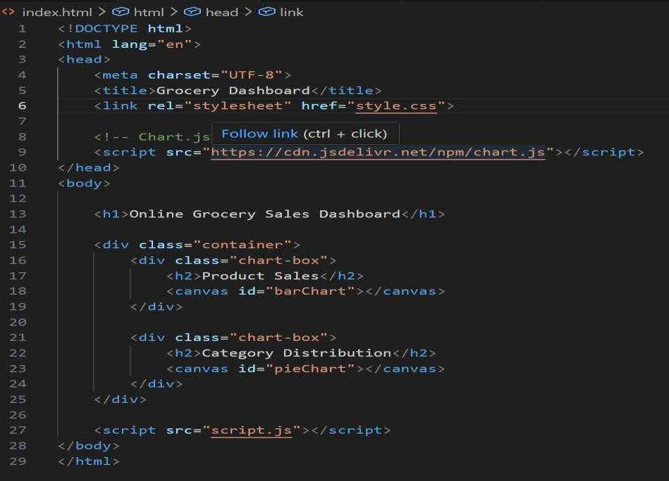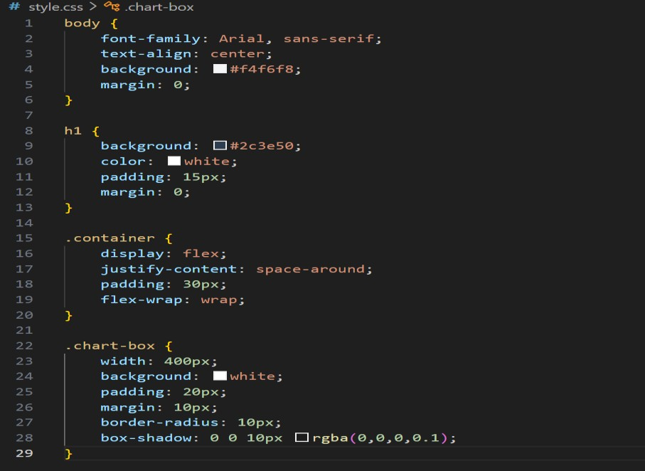

Java Script:
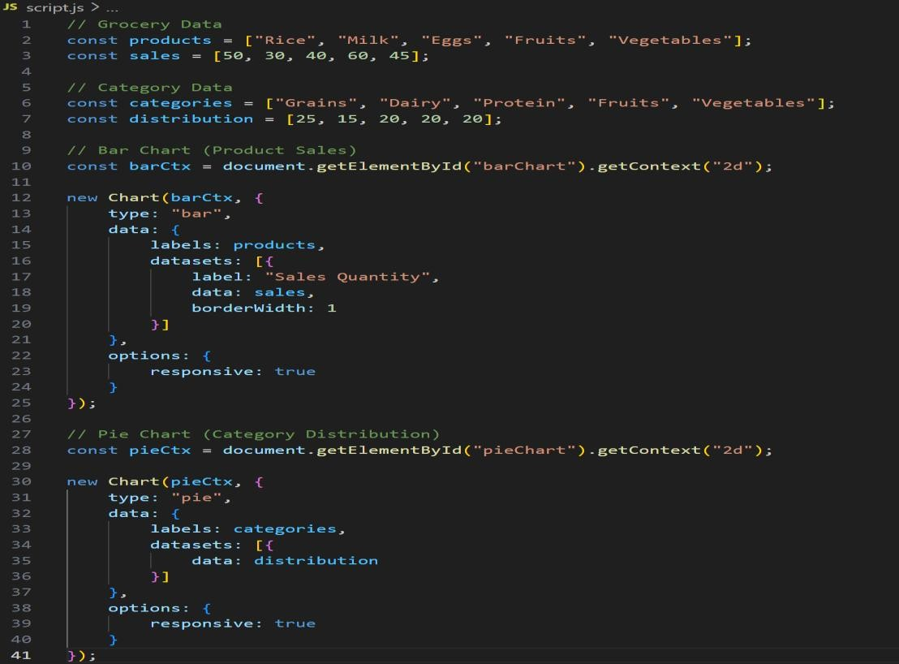

OUTPUT:
- A bar chart showing product-wise sales
- A pie chart showing category-wise distribution

